**MECE Breakdown of the Project**

1. Studied the Data given in each table.
2. What are the insights we can get from each table such that there should not be any Data redundancy.
3. Divided the section into 4 parts :-
4. Actors which include Actors, Actors info and Address Table.
5. Category, City , Country, Customer, Customer list, language, rental table.
6. Film, Film actor, film category, film list, film text.
7. Inventory, Store, Staff, Staff list.
8. Removed all the unnecessary relationship from Model view and did Data Modelling as per the need and in order to make the ER diagram more understandable.
9. Defined several questions in order to have insight from the given data.
10. Prepared several charts in order to support the questions defined in point 5.

**Insights that I got from the above given Dataset :-**

1. Top 10 Actors with most number of Films.

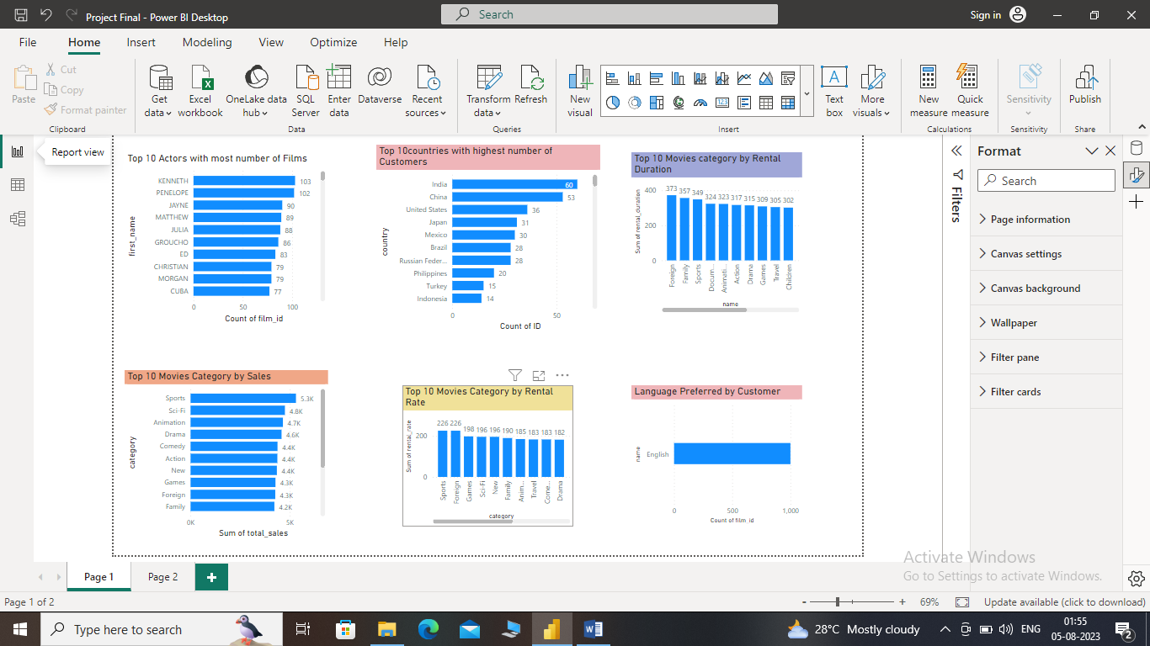

1. Top 10 Countries with highest number of Customers.



1. Top 10 Movies Category by Rental duration.



1. Language preferred by Customers

**English**

1. Top 10 Movies Category by Sales



1. Top 10Movies Category with Highest amount of Rental collection till date.



1. Top 10 highest paying Customers.

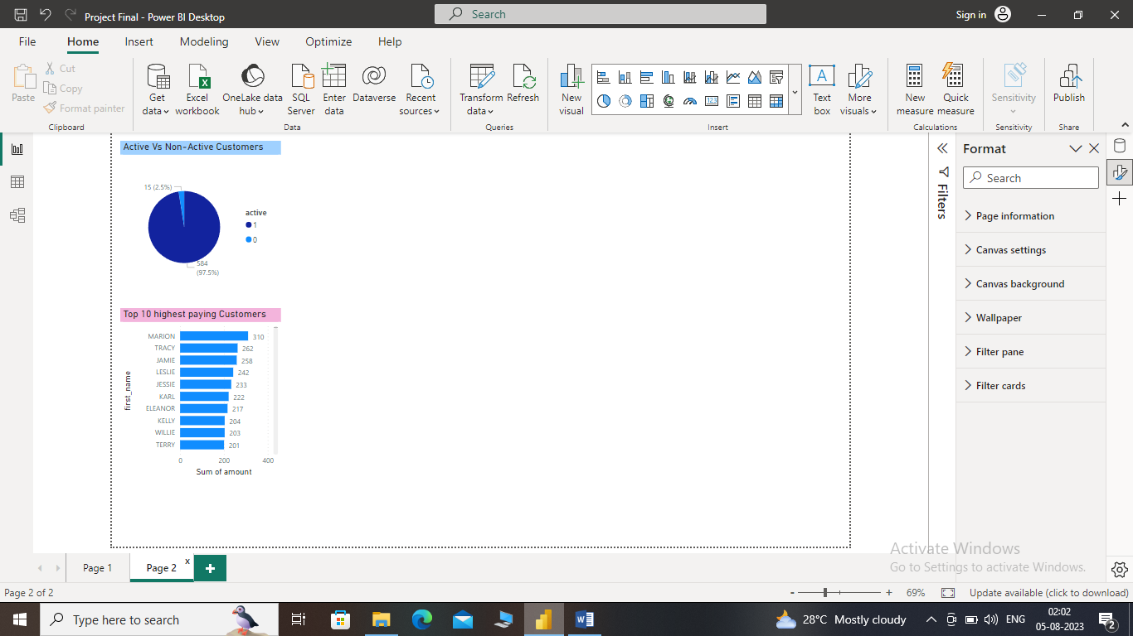

1. Total Number of Active and Non Active Customers.



1. Total number of Actors.

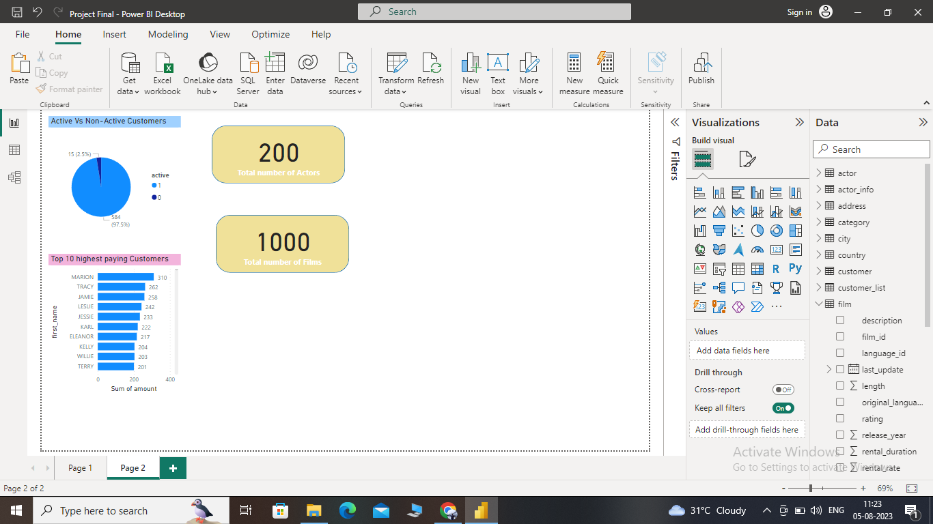

1. Total number of Films.

